Packet Tracer - Troubleshoot HSRP

1. Topology

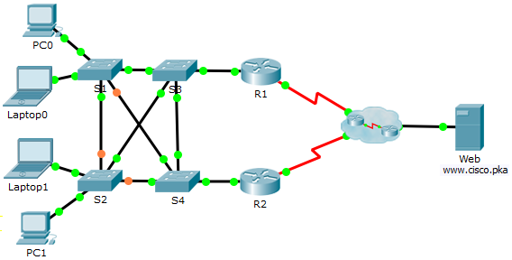

1. Addressing Table

|  |  |  |  |  |
| --- | --- | --- | --- | --- |
| Device | Interface | IP Address | Subnet Mask | Default Gateway |
| R1 | G0/1 | 192.168.1.1 | 255.255.255.0 | N/A |
| S0/0/0 | 209.165.200.226 | 255.255.255.252 | N/A |
| R2 | G0/1 | 192.168.1.2 | 255.255.255.0 | N/A |
| S0/0/1 | 209.165.200.230 | 255.255.255.252 | N/A |
| PC0 | NIC | 192.168.1.10 | 255.255.255.0 | 192.168.1.254 |
| Laptop0 | NIC | 192.168.1.11 | 255.255.255.0 | 192.168.1.254 |
| Laptop1 | NIC | 192.168.1.12 | 255.255.255.0 | 192.168.1.254 |
| PC1 | NIC | 192.168.1.13 | 255.255.255.0 | 192.168.1.254 |
| Web | NIC | 209.165.202.156 | 255.255.255.224 | 209.165.202.158 |

1. Objective

In this activity, you will troubleshoot and resolve the HSRP issues in the network. You will also verify that all the HSRP configurations meet the network requirement.

1. Background / Scenario

Currently the users can access www.cisco.pka. The network has been updated to use HSRP to ensure the network availability to the users. You must verify that the users can still access the website if one of the routers is down. R1 should always be the active router if it is functioning.

Network Requirement:

* HSRP virtual router is 192.168.1.254.
* HSRP standby group is 1.
* DNS server is 209.165.202.157.
* R1 should always be the active router when it is functioning properly.
* R2 uses the default HSRP priority.
* All users should be able to access www.cisco.pka as long as one of the routers is functioning.

1. Troubleshooting Process
   * 1. PCs and Laptops
        1. Verify the PCs and laptops are configured correctly using the provided network requirement.
        2. Based on the Network Requirement shown above, verify that the PCs and laptops can navigate to www.cisco.pka successfully.
     2. Troubleshoot R1.
        1. Disable the interface G0/1 on R2.
        2. Use **show** commands to determine issues. Record and correct any issues found on R1.

____________________________________________________________________________________

____________________________________________________________________________________

____________________________________________________________________________________

____________________________________________________________________________________

* + - 1. Re-enable the interface G0/1 on R2.
    1. Troubleshoot R2.
       1. Disable the interface G0/1 on R1.
       2. Use **show** commands to determine any issues. Record and correct any issues found on R2.

____________________________________________________________________________________

____________________________________________________________________________________

____________________________________________________________________________________

____________________________________________________________________________________

* + - 1. After verifying that the PCs and laptops can navigate to www.cisco.pka successfully, re-enable the interface G0/1 on R1.
    1. Verify connectivity.
       1. Verify all PCs and laptops can navigate to www.cisco.pka.
       2. Verify all the HSRP requirements have been met.